How to create resource group

1. First of all search resource group
2. Then create resource group

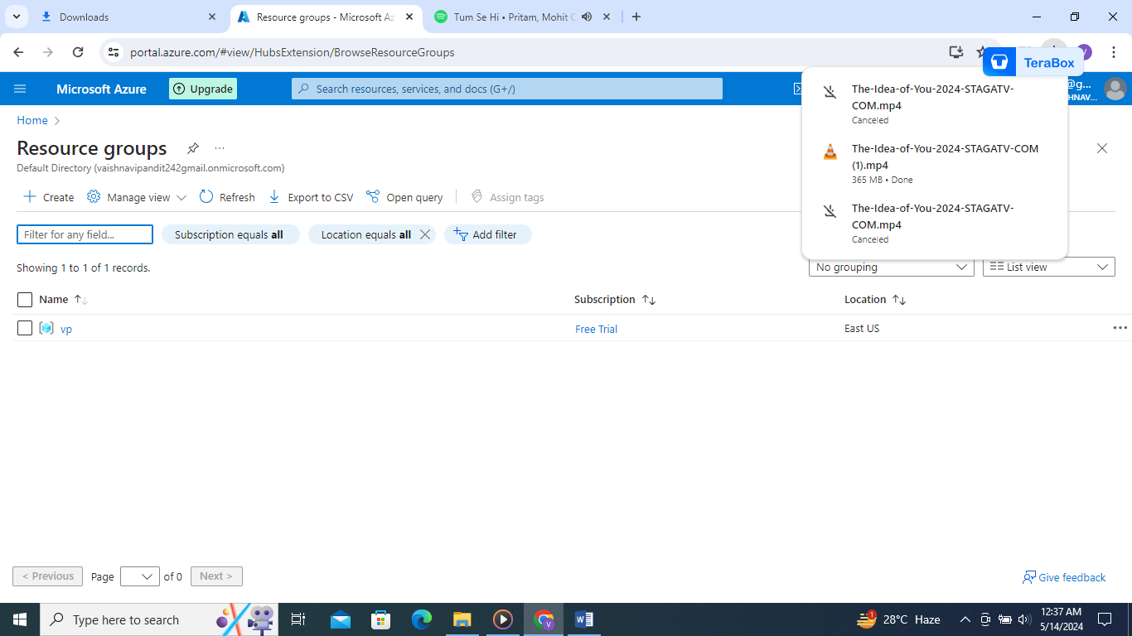

1. Now add name of resource group

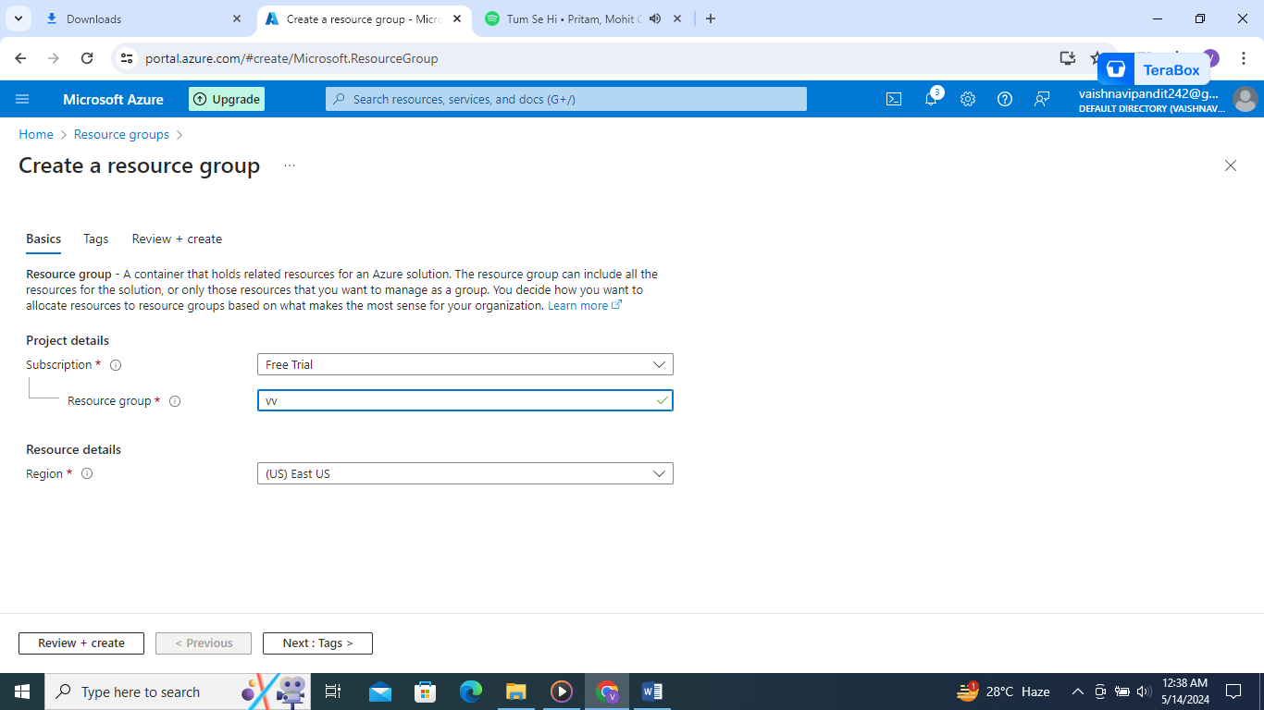

1. Review+create